43.33: a) 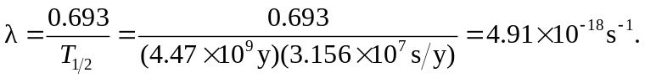
b)

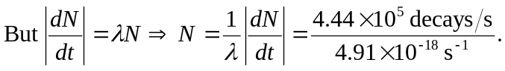

c) Each decay emits one alpha particle. In 60.0 g of uranium there are 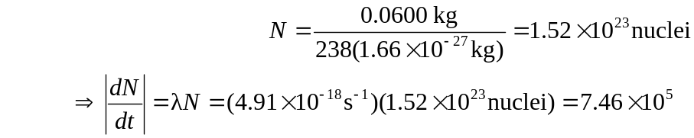
alpha particles emitted each second.

